

**FAKULTI KEJURUTERAAN ELEKTRIK**

SARJANA MUDA KEJURUTERAAN ELEKTRONIK DENGAN KEPUJIAN

**SKEE3223**

**MICROPROCESSOR**

**Project Title:**

**Smart Car Assistant**

**Team Members**

| **Item** | **Full name** | **Photo** | **Matric No.** | **Section** |
| --- | --- | --- | --- | --- |
| **1** | YEOH JETT |  | A23KE0363 | 8 |
| **2** | TEOH SIANG YEW |  | A23KE0345 | 8 |
| **3** | TEE LE XUAN |  | A23KE0482 | 7 |
| **4** | LOOI XIN EN |  | A23KE0181 | 7 |

**1. Task Distribution**

| **Item** | **Name** | **Task** |
| --- | --- | --- |
| **1** | YEOH JETT | * Prototype Development   + Build the prototype and ensure all components are connected and functional. * C programming   + Write and test the program for the project.   + Ensure performs all required functions. |
| **2** | TEOH SIANG YEW | * Connection of circuit diagram   + Design a neat and accurate circuit diagram.   + Verify the accuracy of the circuit design with the prototype. |
| **3** | TEE LE XUAN | * Project results analyzation   + Reviewing project outcomes and system performance. * Prototype Development   + Build the prototype with team members and ensure all components are connected and functional. * Video editing   + Edit and compile the video, make sure the explanation by every member is clear. * Conclusion   + Summarize the outcomes of the project. |
| **4** | LOOI XIN EN | * Abstract   + Write a summary of the project. * List of components   + Identify all components used in the project. * Project flowchart   + Design a flowchart to represent the project's process. * Prototype Development   + Cooperate to build the prototype and ensure all components are connected and functional. |

**2. Abstract**

This project introduces a smart car assistant using an embedded system based on the STM32F4 series microcontroller which is also known as “black pill”. This project has used an ultrasonic sensor, light-dependent resistor (LDR), buzzer and LED to enhance vehicle safety and convenience.

Smart car assistants use sensor-based intelligence for detecting and reacting towards environmental conditions. Ultrasonic sensors are used to measure the distance between the car and surrounding obstacles. A warning alert is triggered when an obstacle is detected within 40 cm and the alert frequency will increase when the distance between car and obstacle decreases. This ensures the driver is notified efficiently.

Besides, smart car assistants will also detect the surrounding light intensity by using a light-dependent resistor (LDR). This is due to smart car assistants able to turn on the light when the light intensity of the surroundings is low and turn off when the light intensity of the surroundings is high. This is able to help the driver by providing good visibility since there are drivers who will forget to turn on the light when the surrounding is dark.

In conclusion, smart car assistants show a practical and innovative approach in order to improve vehicle safety and convenience. This system, combining real-time sensing with intelligent responses, provides benefits for drivers by offering an enhanced driving experience with less risk in ordinary everyday life scenarios.

**3. Components**

| **No.** | **Component** | **Function** |
| --- | --- | --- |
| **1.** | Black Pill    Figure 1.1: Black Pill | Microcontroller that controls input and output. |
| **2.** | Ultrasonic Sensor    Figure 1.2: Ultrasonic Sensor | Measure the distance between the car and an obstacle. |
| **3.** | Light-Dependent Resistor (LDR)    Figure 1.3: LDR | Detects ambient light intensity. |
| **4.** | Buzzer    Figure 1.4: Buzzer | Alerts the driver when the car is too close to an obstacle. |
| **5.** | Light-Emitting Diode (LED)    Figure 1.5: LED | Automatically turns on in low-light conditions. |

**4. Flowchart**

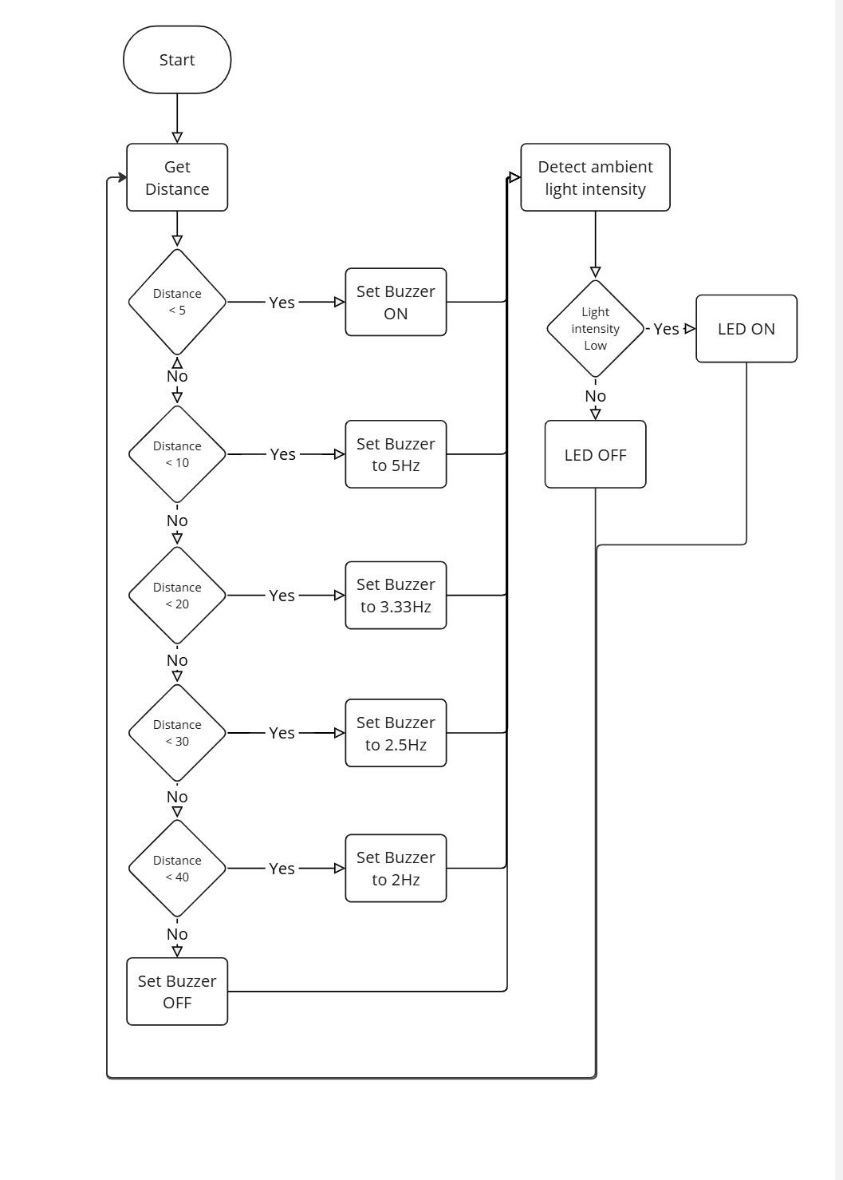

**5. Circuit diagram**

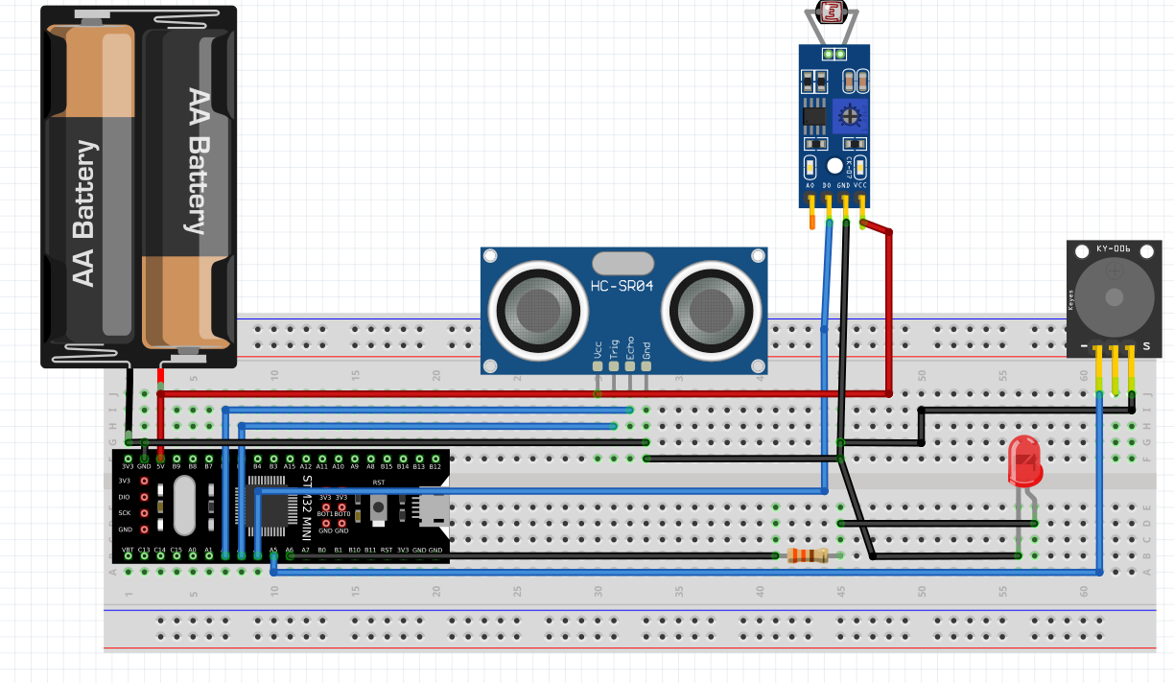 **Figure 5.1 : Software built using Fritzing**

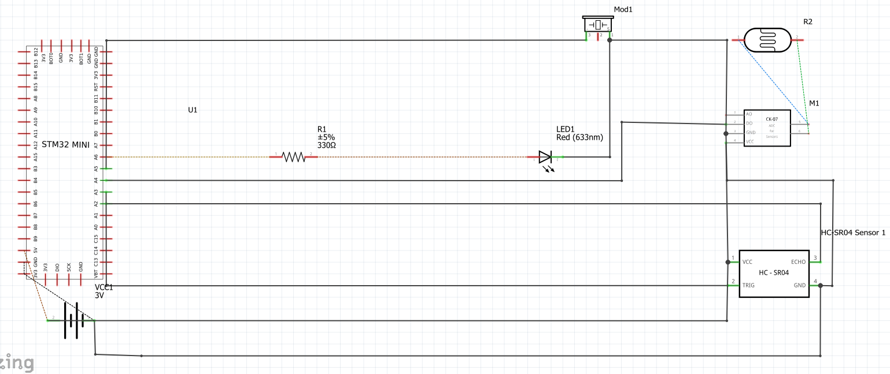

**Figure 5.2 : Schematic diagram of the prototype using Fritzing**

**6. Hardware built**

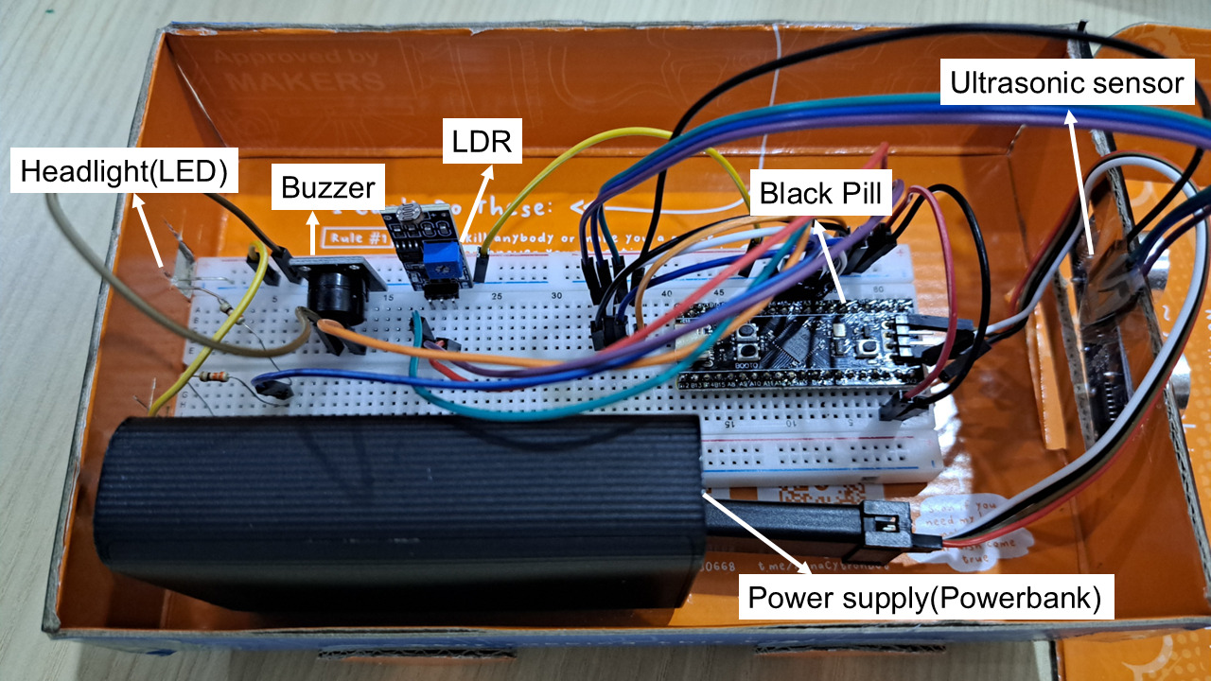

**Figure 6.1: Hardware built with labelling**

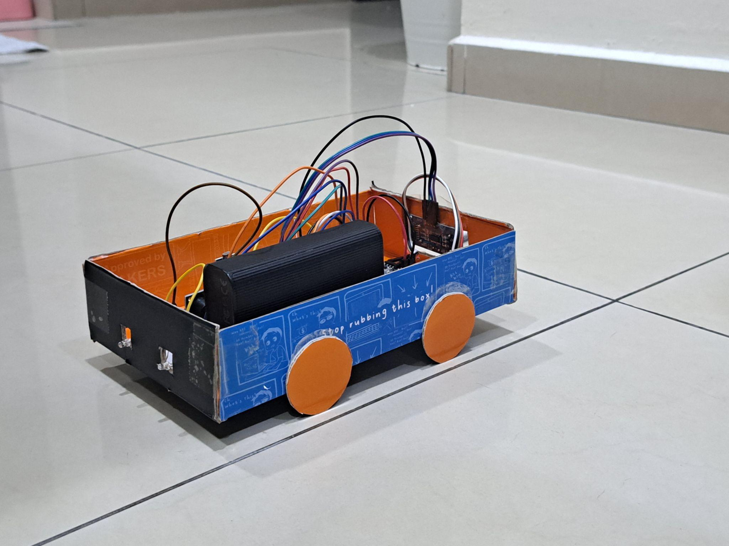

**Figure 6.2: Front view of the hardware built**

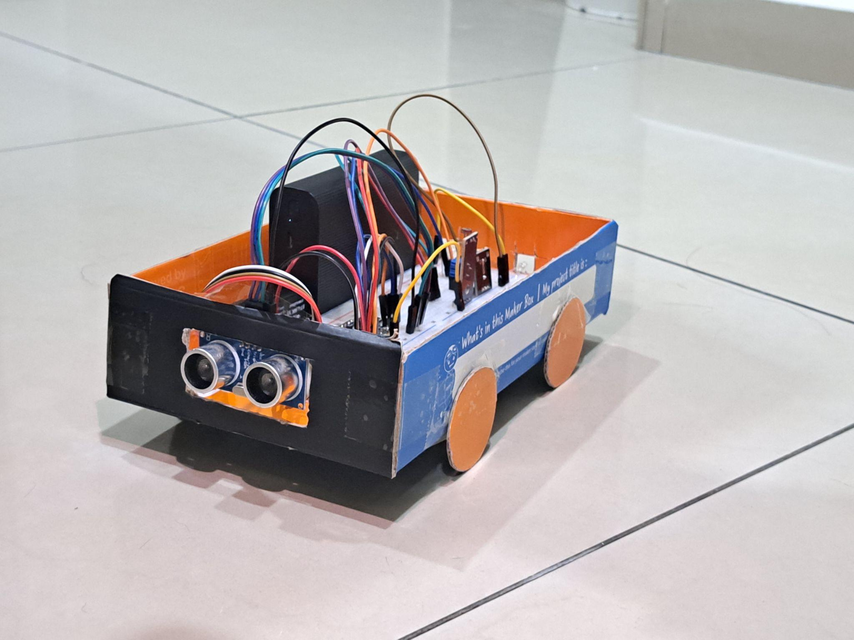

**Figure 6.3: Rear view of the hardware built**

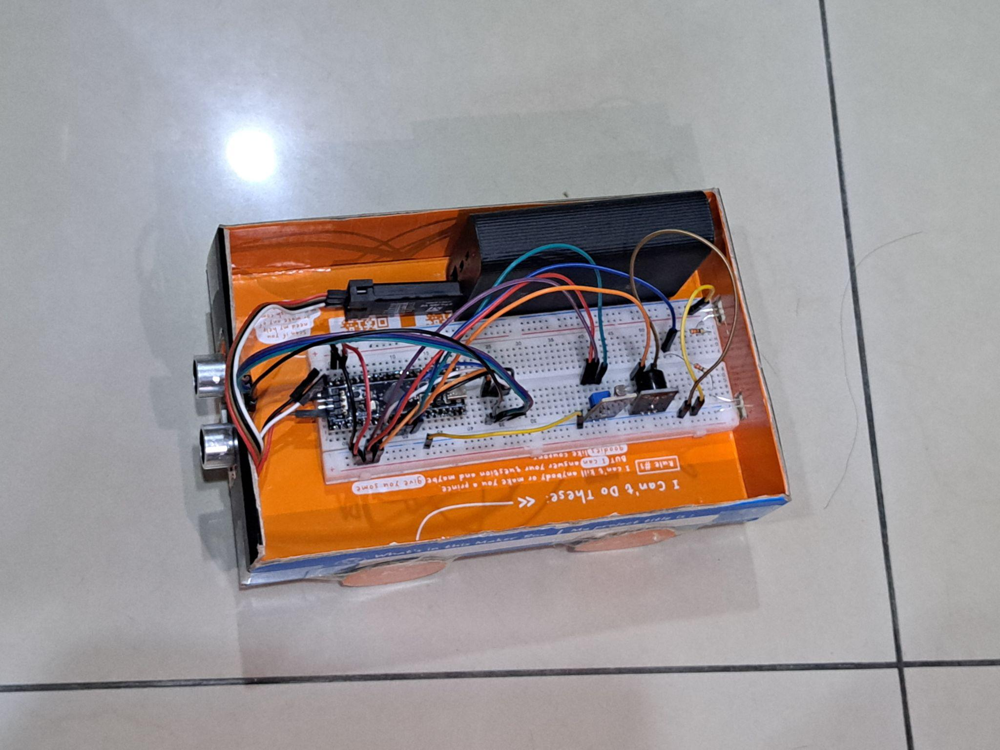

**Figure 6.4: Top view of the hardware built**

**7. Explanation of design functionality**

Setup of Ultrasonic Sensor

Referring to Figure 1.2, the trigger pin (Trig) and echo pin (Echo) are assigned to pins PA3 and PA2, respectively. The trigger pin is configured as a GPIO output with a high maximum output speed, while the echo pin is set to external interrupt mode with rising or falling edge trigger detection. Additionally, the clock is configured to 72 MHz, and TIM3 is used to record the time interval between sending and receiving the ultrasonic wave. The prescaler is set to 71, so each count equals 1 µs. To calculate the distance between the sensor and the obstacle, the formula shown in Figure 7.5 is used.

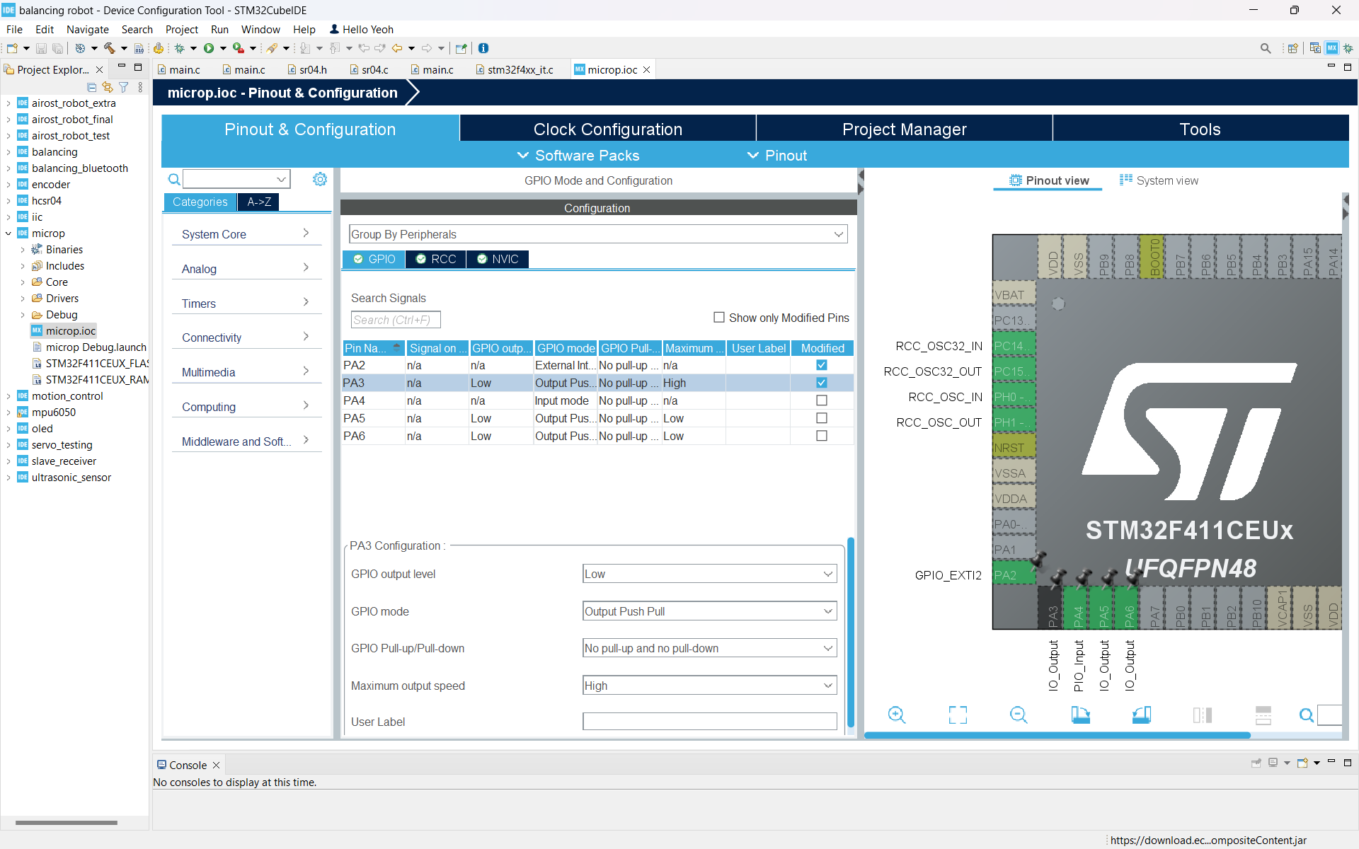

**Figure 7.1: Trigger pin(PA3) configuration**

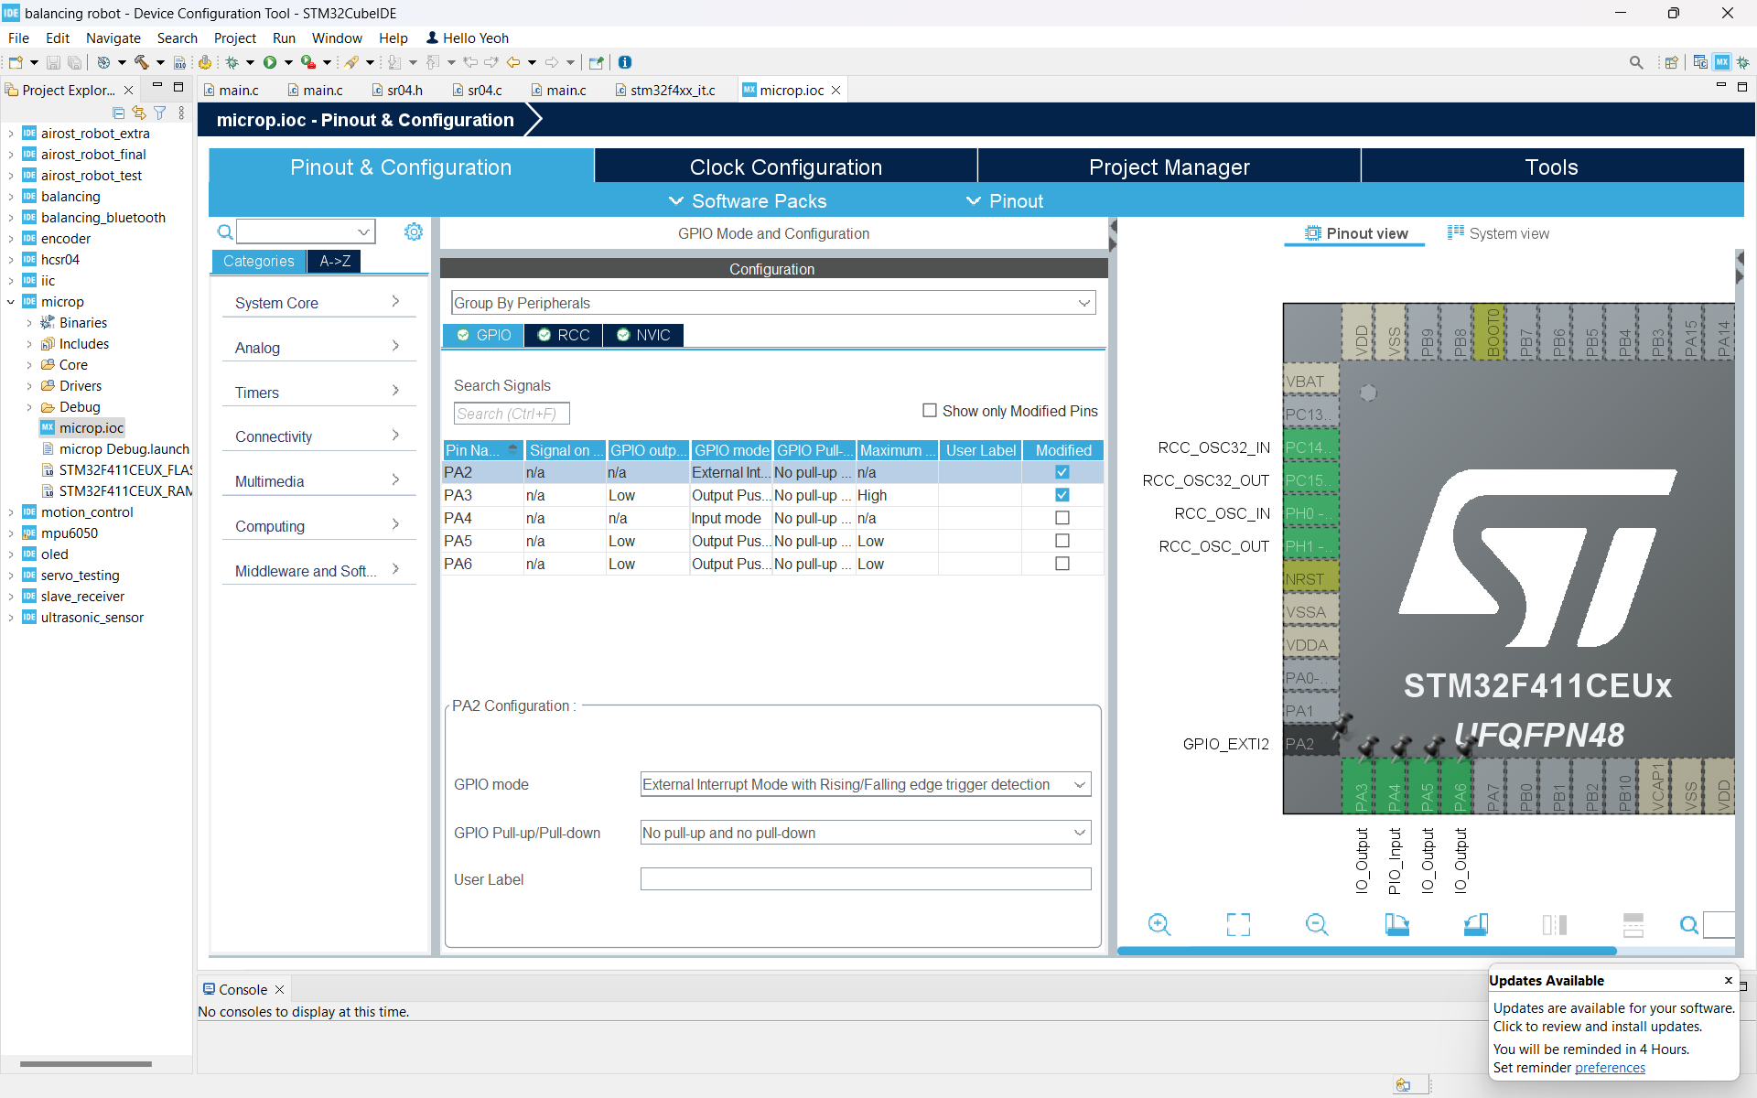

**Figure 7.2: Echo pin(PA2) configuration**

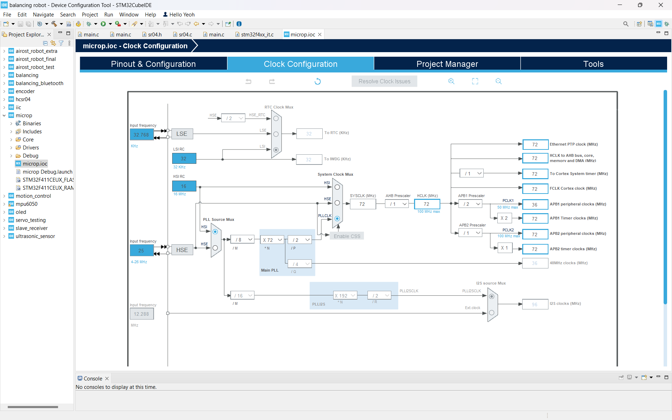

**Figure 7.3: Clock configuration**

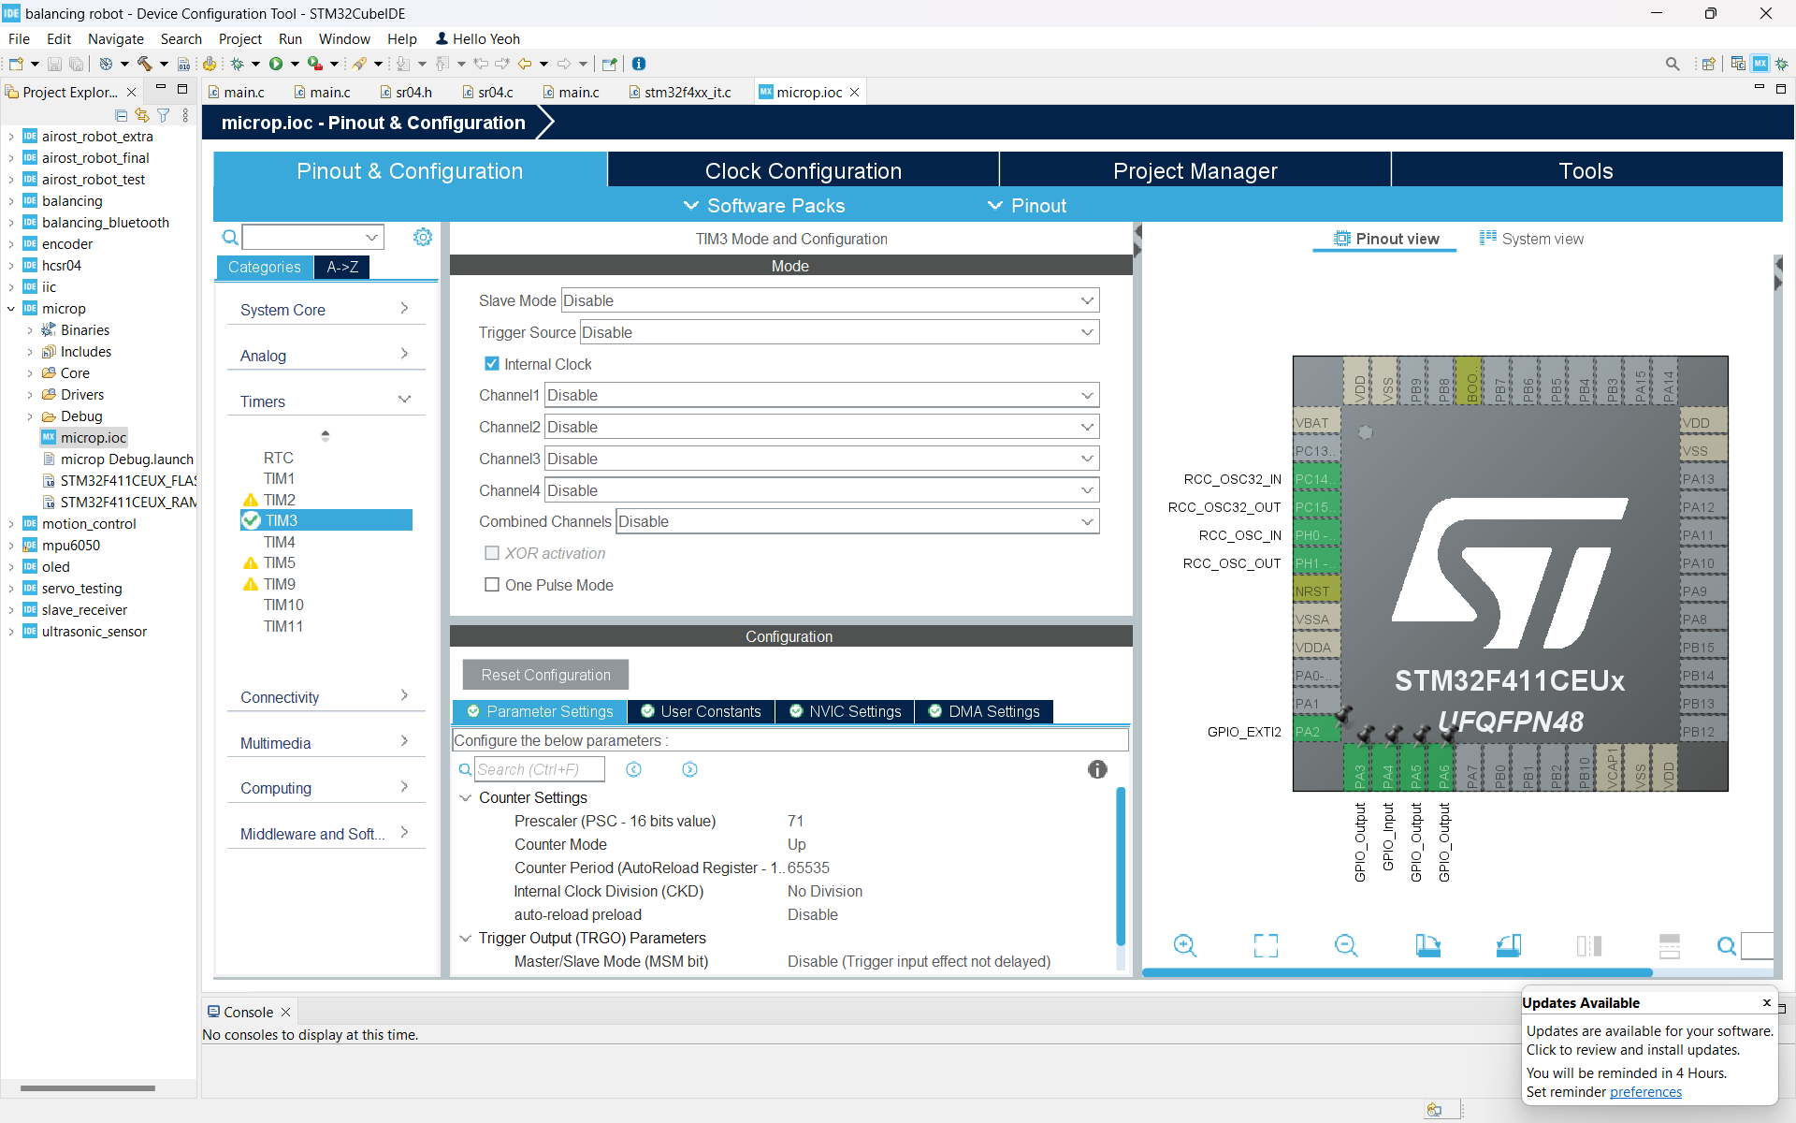

**Figure 7.4: TIM3 Mode and Configuration**

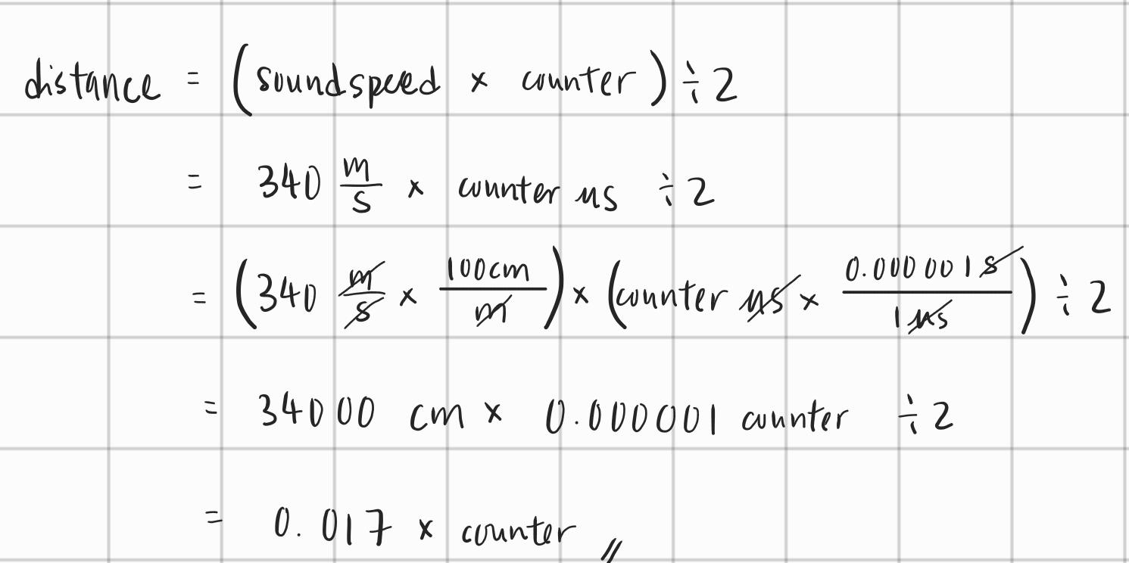

**Figure 7.5: Formula to calculate distance**

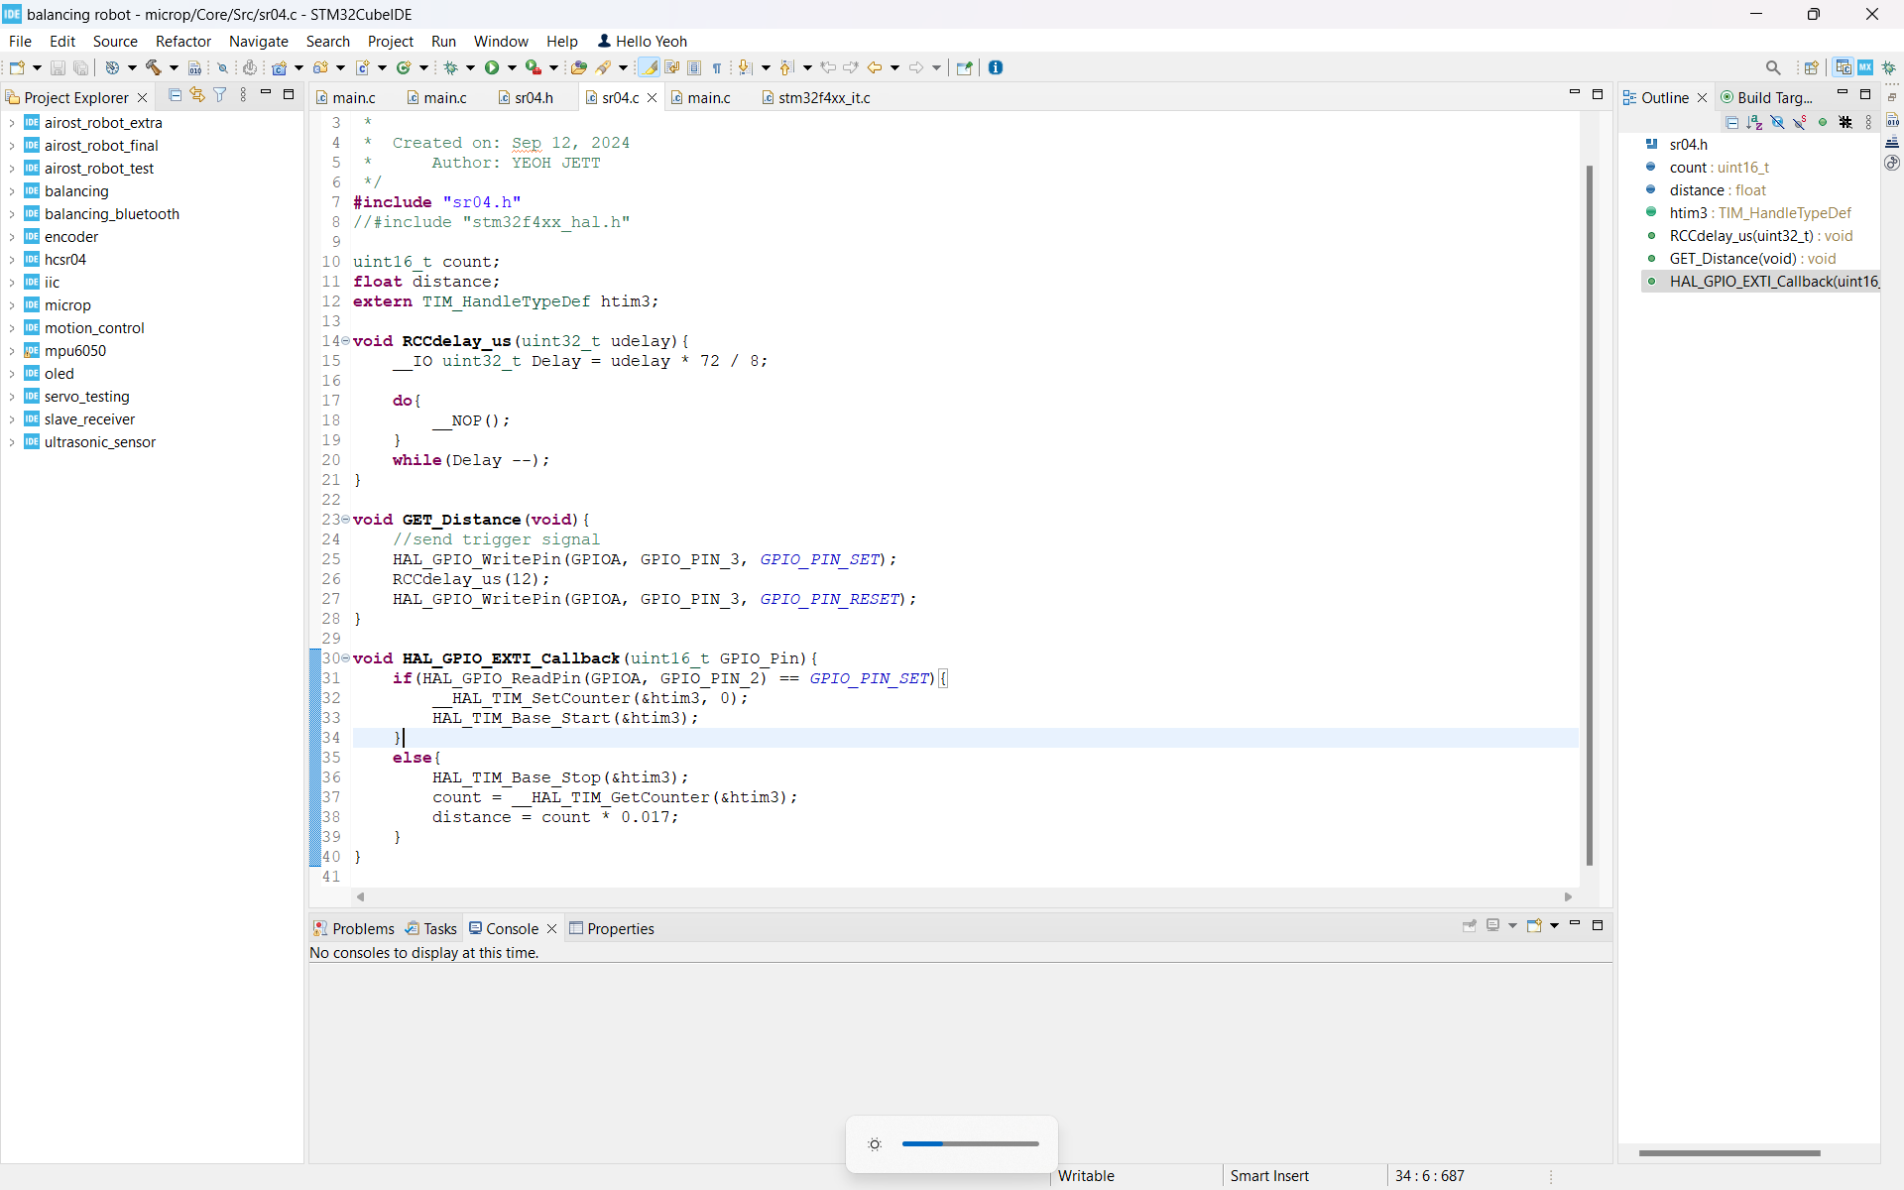

**Figure 7.6: Source code for ultrasonic sensor**

Setup of LDR

The LDR used in this project outputs only a digital value, either 1(Vcc) or 0(Ground). It outputs 0 when the light intensity is high and 1 when the light intensity is low. Therefore, pin PA4 is assigned to the digital output of the LDR and configured as a GPIO input pin to read the digital value sent by the LDR. When PA4 reads 1, the LEDs (headlights) will turn on, and they will turn off when PA4 reads 0.

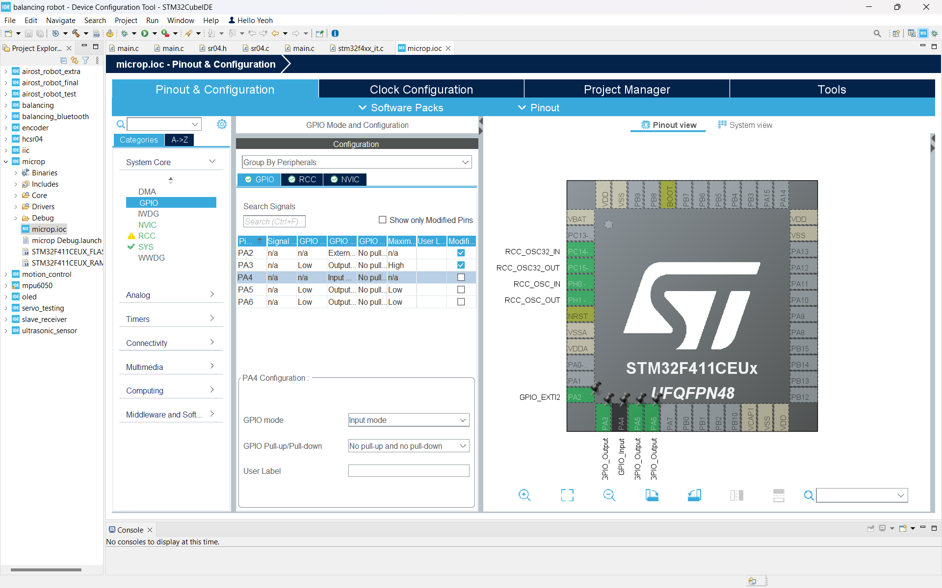

**Figure 7.7: LDR pin(PA4) configuration**

Setup of Buzzer and LED

The buzzer and LED can be controlled using simple digital values, 1 and 0. Therefore, the buzzer and LED are assigned to pins PA5 and PA6, respectively, and both pins are configured as GPIO outputs.

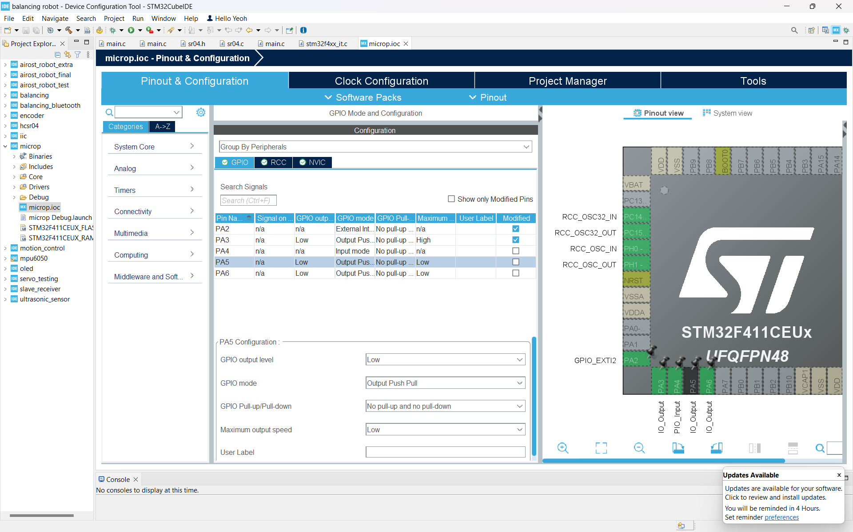

**Figure 7.8: Buzzer pin(PA5) configuration**

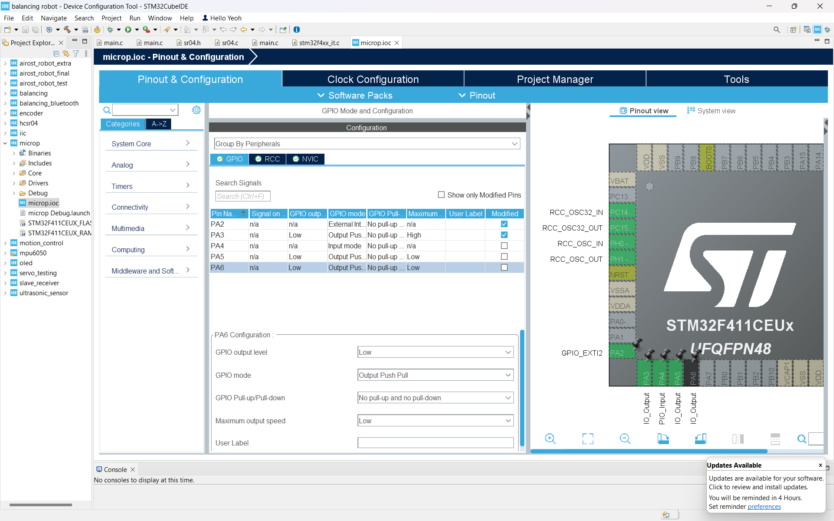

**Figure 7.9: LED pin(PA6) configuration**

Integration of Components

The Black Pill serves as the central hub for coordinating sensor inputs and output actions. The ultrasonic sensor and LDR provide continuous data, which is processed by the microcontroller to determine the appropriate response. The buzzer and LED act as output devices to communicate these responses to the driver. The system operates in real-time, ensuring seamless interaction and responsiveness. Additionally, a power bank is used as the power supply for the system.

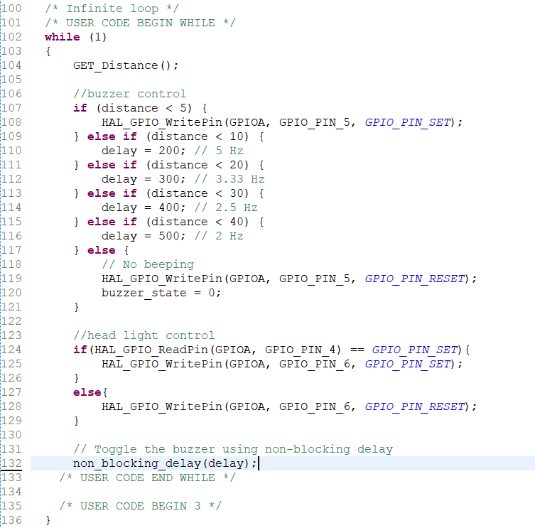

**Figure 7.10: Code snippet of component integration**

**8. Discuss of the results**

Obstacle Detection and Warning System

The obstacle detection system worked as expected in most scenarios. The ultrasonic sensor accurately measured distances and triggered the buzzer alerts at the correct frequency according to the distance between obstacles. However, one issue encountered was that the ultrasonic sensor is sensitive to noise. Occasionally, the sensor would register false readings due to environmental noise, causing the buzzer to emit a short beep even when no obstacle was present. This issue was rare but noticeable. To address this issue, implementing a Kalman Filter or averaging algorithm could help filter out random noise and stabilize the sensor readings.

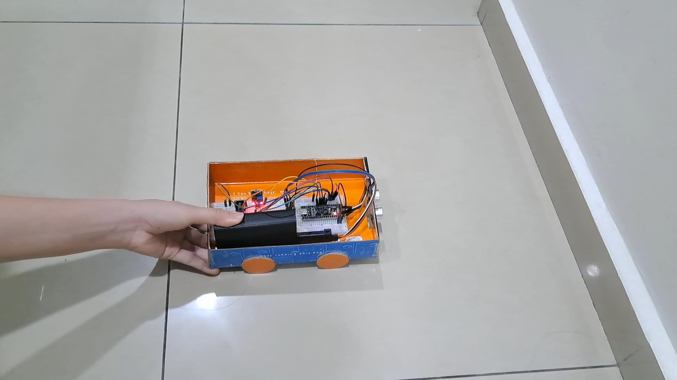

**Figure 8.1: Buzzer successfully produce beep sound in different frequency according to the distance between obstacle**

Automatic Lighting Control System

The LDR successfully detected changes in ambient light intensity and controlled the LEDs accordingly. The headlights turned on in low-light conditions and turned off in bright environments as expected. However, the LDR sensor is affected by its placement and the angle of incoming light. For example, during testing, direct exposure to sudden flashes of light (e.g., from a vehicle's headlights) caused the system to misinterpret the light intensity and turn off the LEDs momentarily, even though the surroundings remained dark. To mitigate this, the LDR sensor could be placed in a more shielded location to minimize the effect of sudden direct light exposure. Additionally, a smoothing algorithm (such as a moving average filter) could be applied to stabilize the readings and avoid abrupt changes in the LED state.

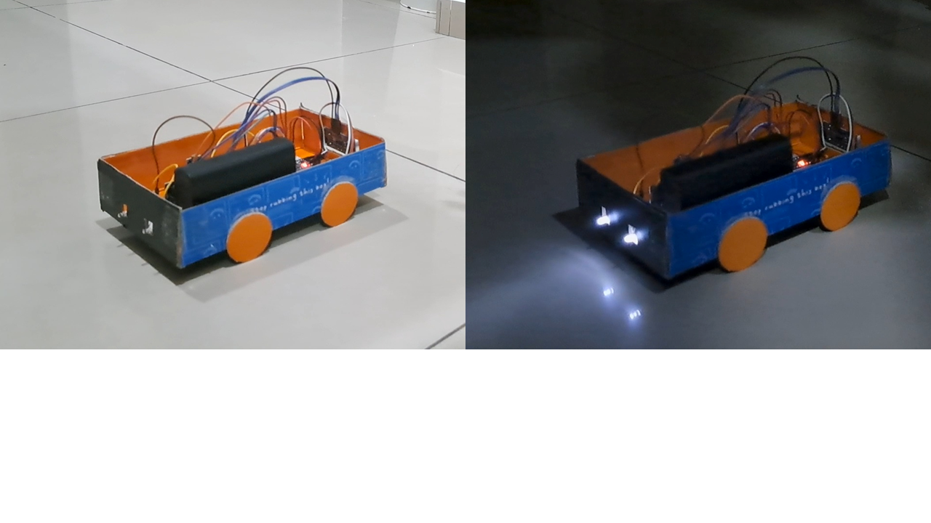

**Figure 8.2: Headlight turned ON successfully according to the surrounding light intensity**

Component Responsiveness

The buzzer and LED respond immediately to changes in sensor input, ensuring real-time operation. The microcontroller processes data and triggers the appropriate outputs without noticeable delay. In order to achieve this, non-blocking delay is used. If a blocking delay is used, the microcontroller would be "stuck" in the delay for a set period, unable to respond to new sensor data. This could lead to missed events, such as obstacles appearing suddenly or light intensity changing rapidly. Besides, non-blocking delays help ensure that the system responds quickly to external events (e.g., detecting obstacles or changes in light). If blocking delays were used, the system could become unresponsive, leading to delays in updating the status of the LEDs or buzzer, which could be critical for safety in the case of obstacle detection. Figure 8.3 and Figure 8.4 show how to perform non-blocking delay.

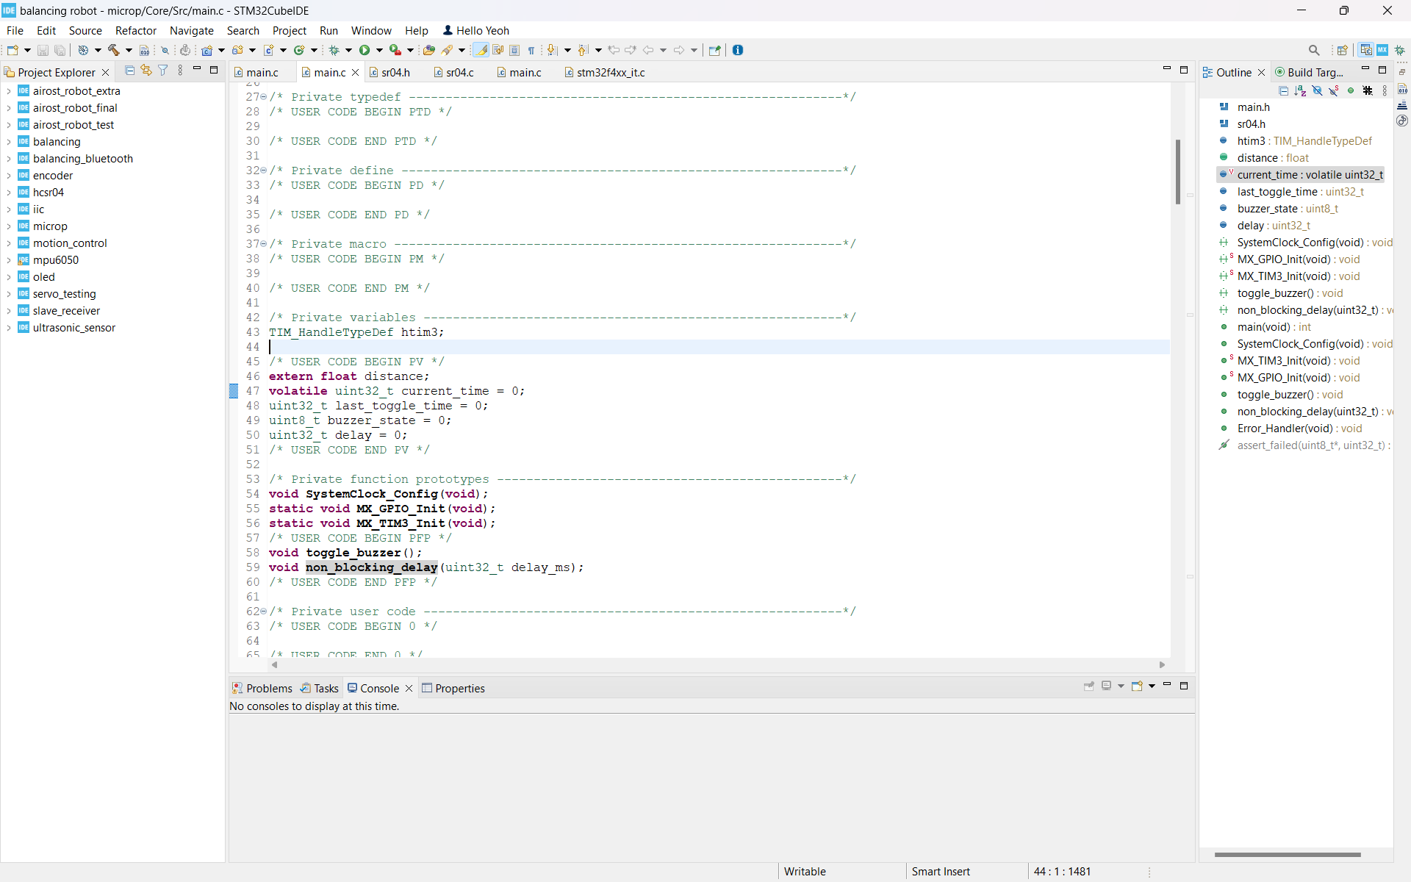

**Figure 8.3: Variables for non-blocking delay function**

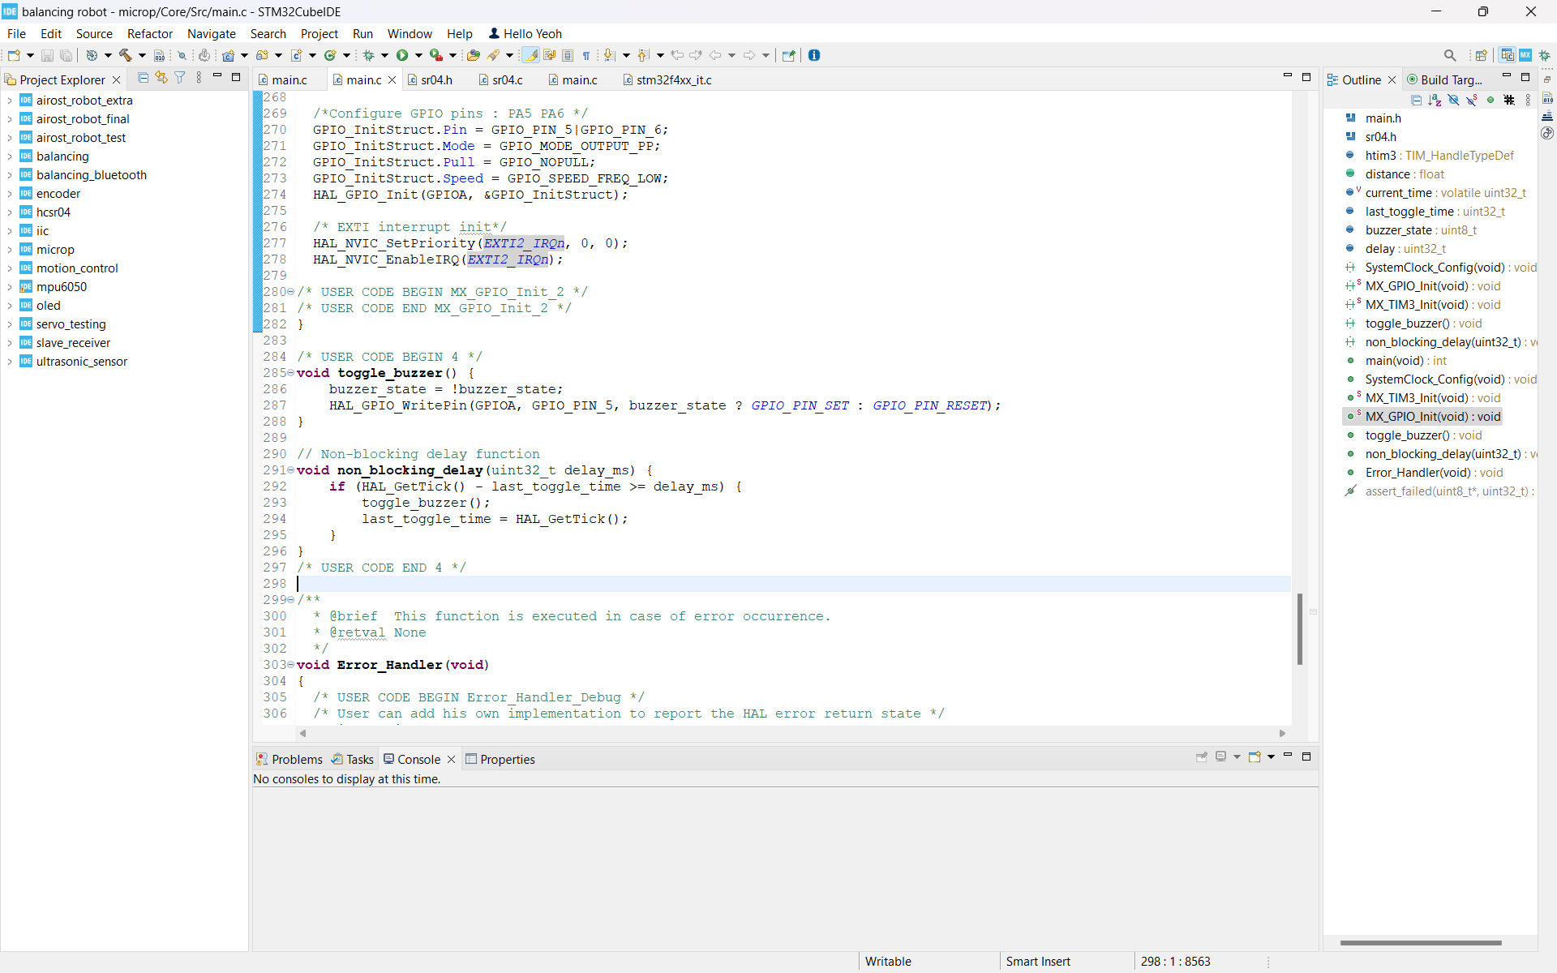

**Figure 8.4: Non-blocking delay function**

Power Supply

The power bank supplies consistent and sufficient power to the system, ensuring uninterrupted operation of the microcontroller, sensors, and output devices.

Overall System Performance

The entire system operates smoothly and integrates seamlessly, enhancing vehicle safety and convenience. The prototype demonstrates reliable functionality in various testing scenarios, including different obstacle distances and lighting conditions.

**9. Conclusion**

The Smart Car Assistant project successfully integrates an embedded system using the STM32F4 series microcontroller to enhance vehicle safety and convenience. In this project, a light - dependent resistor (LDR) sensor, a buzzer and LEDs are used to utilize ultrasonic sensors. An effective obstacle detection demonstration is shown, with the ultrasonic sensor accurately measuring the distances and triggering alerts based on proximity. The automatic lighting control feature ensures the headlights of the car turn on in low-light conditions and off in bright environments, improving driving safety.

In conclusion, the Smart Car Assistant is a practical and innovative solution for improving driving safety and convenience. It showcases how embedded systems can be effectively used in automotive applications, creating further advancements in smart vehicle technology

**10. References**

1. *STM32F4 series - STMicroelectronics*. (n.d.). STMicroelectronics. <https://www.st.com/en/microcontrollers-microprocessors/stm32f4-series.html>
2. Teja, R. (2024, September 11). *200+ latest Electronics projects for engineering students*.ElectronicsHub.

<https://www.electronicshub.org/electronics-projects-ideas/>

1. Gravekamp, T. (n.d.). STM32F411CEU6 - WeAct Black Pill v2.0. STM32-base Project. <https://stm32-base.org/boards/STM32F411CEU6-WeAct-Black-Pill-V2.0.html>
2. MaxBotix. (n.d.). *What is an ultrasonic sensor?* <https://maxbotix.com/blogs/blog/how-ultrasonic-sensors-work?srsltid=AfmBOoo8Rw1RYmSnswe_lZlg5qB5b_IOHZEG1-GpfFuuRS9wHPjSiz-z>
3. *Arduino Light Sensor Circuit using LDR*. (n.d.). <https://circuitdigest.com/microcontroller-projects/arduino-light-sensor-using-ldr>
4. *The road to a smarter future: the smart city, connected cars and autonomous mobility*. (2021, September 2). IEEE Conference Publication | IEEE Xplore. <https://ieeexplore.ieee.org/document/9594125>

**11. Coding Link**

<https://github.com/jettyeoh/Smart-Car-Assistant.git>

**12. Video Submission Link**

<https://youtu.be/QE0WGA7-tKs>